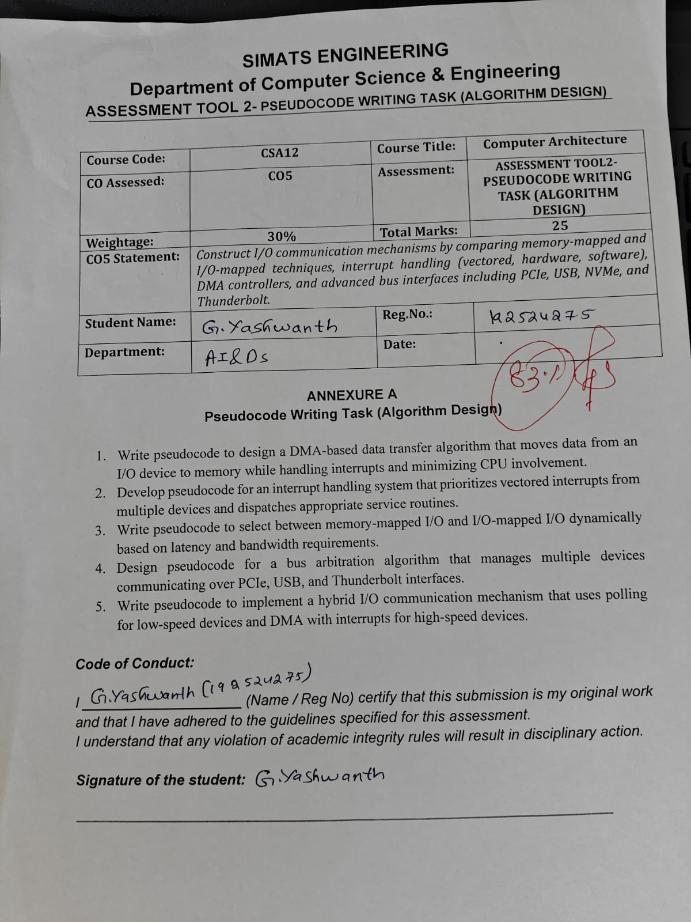



1. DMA-Based Data Transfer Algorithm
Purpose: Transfer data from an I/O device to memory with minimum CPU involvement.
BEGIN

Initialize DMA Controller
Initialize I/O Device
Set Source = I/O Device
Set Destination = Main Memory
Set Transfer Size

Enable DMA

Start DMA Transfer

WHILE transfer is not complete
CPU performs other tasks
END WHILE

DMA generates interrupt

IF interrupt received THEN
Check transfer status

IF transfer successful THEN
Display "Transfer Completed"
ELSE
Display "Transfer Error"
END IF
END IF

Disable DMA

END
Key point: DMA transfers data directly to memory, so CPU involvement is low.

2. Vectored Interrupt Handling
Purpose: Give priority to interrupts from multiple devices and execute the correct ISR.
BEGIN

Initialize Interrupt Controller
Set Priority for each device
Enable Interrupts

WHILE system is running

IF interrupt occurs THEN

Identify interrupt source

Select highest-priority interrupt

Get interrupt vector

Call corresponding ISR

Execute ISR

Clear interrupt flag

Return to previous task

END IF

END WHILE

END

Simple flow
Devices
↓
Interrupt Controller
↓
Check Priority
↓
Get Vector
↓
Execute ISR
↓
Return to Task

3. Dynamic I/O Selection
Purpose: Select memory-mapped I/O or I/O-mapped I/O according to system requirements.
BEGIN

Read latency requirement
Read bandwidth requirement

IF latency requirement is HIGH THEN
Select Memory-Mapped I/O

ELSE IF bandwidth requirement is HIGH THEN
Select Memory-Mapped I/O

ELSE
Select I/O-Mapped I/O
END IF

Configure selected I/O method

Start I/O operation

END

Simple decision
I/O Requirement
↓
Check Latency
↓
High? ── Yes ──→ Memory-Mapped I/O
↓ No
↓
Check Bandwidth
↓
High? ── Yes ──→ Memory-Mapped I/O
↓ No
↓
I/O-Mapped I/O
Key point: Memory-mapped I/O is preferred when fast access and high performance are required.

4. Bus Arbitration Algorithm
Purpose: Manage multiple devices using PCIe, USB, and Thunderbolt fairly.
BEGIN

Initialize PCIe devices
Initialize USB devices
Initialize Thunderbolt devices

Create device queue

WHILE devices need bus access

Check all requesting devices

IF high-priority request exists THEN
Grant bus to high-priority device
ELSE
Select next device using Round-Robin
END IF

Allow device to use bus

Complete data transfer

Release bus

Move to next device

END WHILE

END

Simple flow
Devices
↓
Check Requests
↓
Priority Check
↓
Round-Robin Selection
↓
Grant Bus
↓
Data Transfer
↓
Release Bus
Key point: Round-robin arbitration provides fair access and prevents starvation.

5. Hybrid I/O Communication
Purpose: Use polling for low-speed devices and DMA with interrupts for high-speed devices.
BEGIN

Initialize all devices

FOR each device

Check device speed

IF device is LOW-SPEED THEN

Use Polling

WHILE data is available
Read data
END WHILE

ELSE

Use DMA

Start DMA transfer

WAIT for DMA interrupt

IF interrupt received THEN
Check transfer status
Process data
END IF

END IF

END FOR

END

Simple flow
Device
↓
Check Speed
↙ ↘
Low Speed High Speed
↓ ↓
Polling DMA
↓
Interrupt
↓
Process Data

